Enterprise Architecture Framework
NextGen HR & PAY

GCDocs: 34007576
Version 0.2

May 30, 2019

Purpose of this document
This document provides a framework for the practice of enterprise architecture to support the NextGen HR & PAY initiative (http://www.tbs-sct.gc.ca/next-gen-prochaine/next-generation-human-resources-pay-system-public-service.html).
The objectives of the framework are to communicate a consistent approach to deliver high quality NextGen HR & PAY architecture deliverables and to include agility by allowing “just enough” structure, which can be created “just in time” to meet the transformational requirements of NextGen HR & PAY.
The framework will follow an information driven approach and it will be used to inform the development, management, and communication of enterprise architecture work products to guide NextGen HR & PAY investment decisions.

Executive summary
An Enterprise Architecture (EA) framework provides a collection of best practices, standards, tools, processes, and templates to assist in the creation of the Enterprise Architecture and architectures of various scopes. Enterprise Architecture frameworks generally include:
- A common vocabulary driven by a taxonomy
- Guiding principles which influence how the architecture method is applied
- Reference models and reference architectures
- Guidance on previous architecture decisions, strategies, standards and the architecture method
- A repository of architecture deliverables and artifacts
EA frameworks have the goal of addressing the basic challenge of assessing, aligning, and organizing business objectives with technical requirements and strategies. NextGen HR & PAY is utilizing an Enterprise Architecture framework in order to leverage best practices to guide and manage the process for creating and maintaining architectures.
There are numerous generally accepted enterprise architecture frameworks to leverage from across industry and the public sector, however each framework has its own benefits and drawbacks, which makes it difficult to find a single framework that can be used for all situations.
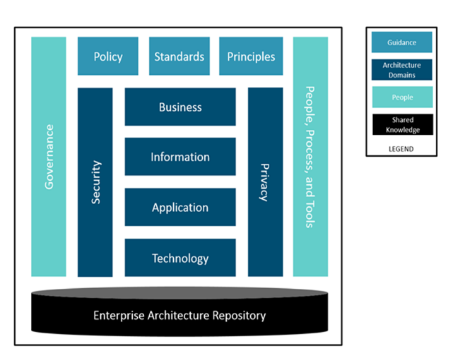
NextGen HR & PAY requires a business driven framework to help align the Government of Canada’s business, data and technology strategies. The NextGen HR & PAY EA Framework (EAF) provides a simple, yet practical and prescriptive, approach to enterprise architecture. The EAF provides agility thereby allowing “just enough” structure, which can be created “just in time” to meet the business needs of NextGen HR & PAY.
Figure 1: NextGen HR & PAY Enterprise Architecture Framework
The EAF is divided into four main categories: Guidance, Architecture Domains, People and Shared Knowledge. The EAF leverages: The Open Group Architecture Framework (TOGAF®) for its process methodology to do architecture, the concept of reference models to classify the architecture data; the usage of ArchiMate 3.0.1 to describe the architecture domains and their relationships; Managing Successful Programs (MSP) to guide program and delivery and projects to realize NextGen HR & PAY architectures; and Information Technology Information Library (ITIL) to include service management.
Contents
Purpose of this document 2
Executive summary 3
Enterprise Architecture Overview 6
The Need for Enterprise Architecture 6
Enterprise Architecture Benefits 7
Implementing Enterprise Architecture 8
Enterprise Architecture Framework Description 9
Guidance 10
Policy 10
Standards 10
Principles 11
People 12
Governance 12
Governance Aspects 12
Organizational Model 13
Services Catalogue 14
Communication 15
Process 15
Architecture Method 15
Reference Architectures 17
Current State Architecture 18
Target State Architecture 18
Roadmap 19
Operating Model 19
Tools 20
Metamodel 21
Architecture Views 22
Reference Models 26
Linking Reference Models to TOGAF® 32
Maturity Model 39
Architecture Domains 42
Business Architecture Domain 42
Information Architecture Domain 42
Application Architecture Domain 43
Technology Architecture Domain 43
Security Architecture Domain 44
Privacy Architecture Domain 44
Shared Knowledge 44
Strategy 44
Enterprise Architecture Repository 45
Enterprise Architecture Reference Content 47
Reference Architectures 47
Current State Architecture 47
Target State Architecture 48
Architecture Assessments 48
Architecture Significance Details 49
Application Portfolio Management 50
References 52
Glossary 52
Contact 52

Enterprise Architecture Overview
Enterprise Architecture (EA) identifies the business processes and data that execute or support an organization’s mission and defines how Information Technology (IT) assets directly enable those processes. The purpose of EA is to optimize and transform the processes, information, application systems and technologies into an efficient, secure and integrated environment supportive of the execution of business strategy.
To help execute business strategy and realize strategic goals, EA defines a desired target state view of an enterprise’s processes, information, application systems and technologies and an enterprise roadmap to progressively implement this target state through a series of investment decisions. In order for the enterprise to achieve its desired change, it must be integrated with other management functions, activities and practice areas, such as: strategic planning, project management, portfolio management, and management and oversight.
Enterprise Architecture facilitates business and IT communications with common language, process and structure.
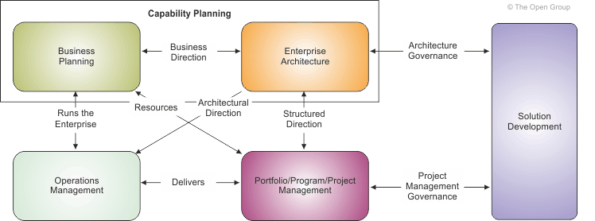
Figure 2: Role of Enterprise Architecture
Source: http://pubs.opengroup.org/architecture/togaf9-doc/arch/index.html

The Need for Enterprise Architecture
In order to achieve target business outcomes and drive business forward, institutions establish goals and objectives through strategic planning. A business outcome driven approach is used to analyze and determine the necessary improvements to business processes, data and IT assets is in support of achieving target business outcomes. EA helps identify these necessary improvements and how to progressively implement those improvements by defining the desired target state and an enterprise roadmap. In defining the desired target state, EA leverages or creates best practice based solutions which contribute to building business and technical capabilities that can be reused and shared throughout the enterprise.
The strategic context provided by EA through the desired target state architecture and enterprise roadmap is important to make sure individual projects build business and IT capabilities in support of the long-term business strategy – rather than just fulfill immediate tactical needs.
A well-defined EA framework enables the definition and modeling of the enterprise in its entirety and across all of its dimensions and complexity. The dimensions include the business and its mission and services, how the enterprise is organized and how it works, and then it is linked to the information, applications and technology investments and services.

Enterprise Architecture Benefits
When EA is effectively defined, implemented and followed, it can provide the following key benefits:
- Linking business strategy and implementation: By defining the target business processes and IT assets required to satisfy the business objectives, and a roadmap for reaching that target, EA provides a clear vision to implement business strategy and helps reduce ad-hoc implementations driven by a tactical and reactive approach.

- Improving alignment of IT with mission, goals, and objectives: By identifying how IT assets directly enable business processes and how those processes execute the organization’s mission, EA promotes IT solutions that are relevant for the business.

- Improving service delivery, business operations and business capabilities: Adoption of EA results in streamlining business processes and in making IT operations more efficient. EA processes help to identify gaps in business capabilities and provide a long-term vision to improve and/or acquire those capabilities.

- Improving interoperability and information sharing: By defining enterprise wide standards and specifications for how systems will “talk to each other”, EA makes the job of integrating multiple systems and sharing information easier.

- Improving agility and adaptability: EA enables faster design of new services and extensions to existing services by pre-defining standards and repeatable patterns.

- Reducing redundancy, duplication, complexity and information silos: EA enables portfolio rationalization and simplification to promote more effective use of capabilities and resources to efficiently support business processes.

- Reducing business risk associated with IT and reduce risk for future IT investment: Focus on strategic goals allows EA to identify weaknesses and threats in the existing portfolio and to address them in the target architecture. The risk of future IT investments not delivering business value is greatly reduced when investments are made in accordance with a well-defined enterprise roadmap.

- Enable faster, simpler and cheaper procurement: By defining the target architecture and a roadmap, EA simplifies procurement decisions.

- Enable predictable success of projects and realization of their defined objectives: EA promotes undertaking projects within the context of a defined enterprise roadmap. EA provides guidance to these projects to ensure their progress towards the target architecture and to help realize their defined business objectives.

Implementing Enterprise Architecture
EA is about the whole enterprise – not just about IT. The following key activities are intended to outline the investments required to deliver EA:
- Establish an architecture team and charter them to provide clearly defined services and deliverables
- Adopt an enterprise architecture framework to provide:
  - A common language to describe architecture
  - An architecture description (I.e. metamodel) that describes the relationship between the architecture domains of business, information, application, technology and security to investments and performance.
  - Effective methods, tools and guidance for developing actionable EA deliverables
  - EA governance and communication
  - Best-practice-based solutions to build common business and/or technical capabilities
- Analyze the business strategy and goals, and understand the business operating model
- Define a set of principles, enterprise-level requirements and constraints for the architecture
- Divide the EA into segments, and prioritize the EA work across these segments to incrementally develop EA in accordance with the business priorities
- Determine target maturity levels across EA segments to support the business operating model and long-term business strategy
- Develop and communicate the EA Plan including its incremental and federated approach, and gain stakeholder support
- Execute the EA Plan to incrementally define target state EA and a roadmap
- Measure the progress, maturity and effectiveness of the EA program, and adjust as necessary

A successful EA is not a one-time deliverable or effort but an ongoing management discipline featuring the continual evolution of alignment with the evolving business and transformation needs and the priorities in order to achieve the future state EA. The value of EA can be identified by measuring the effectiveness of EA deliverables and services in enabling the enterprise to achieve its target business outcomes and priorities.
EA’s impact on the business outcomes should be identified and communicated in terms of EA’s influence on which projects are identified and initiated, and how these projects are directed in alignment with the target architecture and the enterprise roadmap. The business outcomes are actually achieved by the projects and activities rather than directly by EA.

Enterprise Architecture Framework Description
There are numerous generally accepted enterprise architecture frameworks to leverage from across industry and each has its benefits and drawbacks, which makes it difficult to find a single framework that can be used for all situations.
The recommended framework to follow leverages: The Open Group Architecture Framework (TOGAF®) for its process methodology to do architecture, the concept of reference models to classify the architecture data; the usage of ArchiMate 3.0.1 to describe the architecture domains and their relationships; Managing Successful Programs (MSP) to guide program delivery and projects to realize NextGen HR & PAY architectures; and Information Technology Information Library (ITIL) to include service management.
The described architecture method aims to: be driven by business strategy, standardize the architecture description, encourage the need for minimal modelling to meet architecture requirements, leverage existing best practices and reference architecture content, and support agile architecture delivery.
A summarized view of the EA framework is illustrated below. 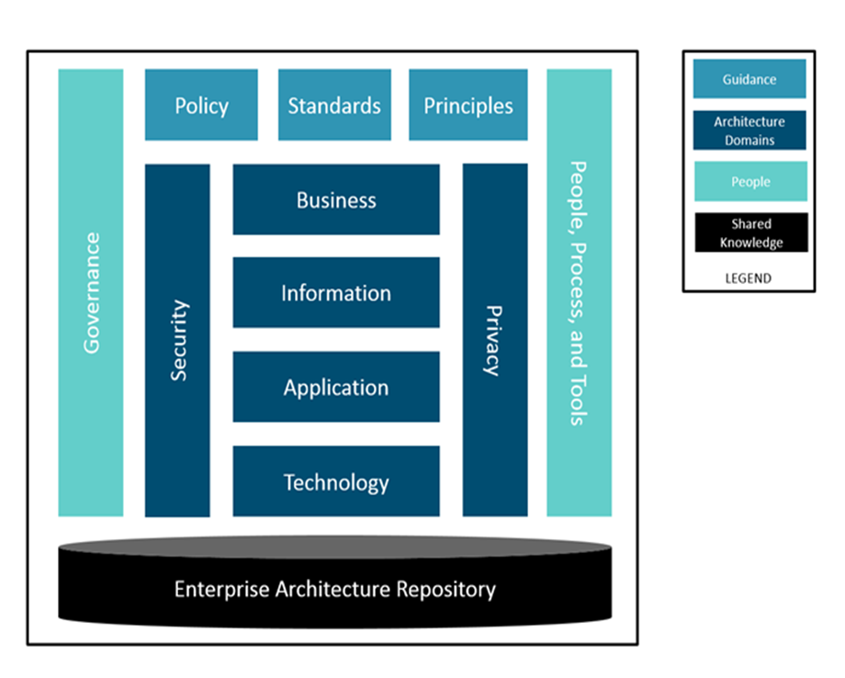
Figure 3: NextGen HR & PAY Enterprise Architecture Framework

Guidance

Policy
Policies are the specific rules and guidelines that detail and guide the way in which an organization sets about fulfilling its mission.
The framework will adhere to all Government of Canada policies outlined at http://www.tbs-sct.gc.ca/pol/index-eng.aspx.

Standards
Standards are the prescribed or preferred technology, design, data, and process elements that conform to architectural principles. Standards are the legal and regulatory, industry defined, or generally accepted best practices for addressing business problems.
At minimum, the framework will adhere to the Government of Canada Digital Standards (https://www.canada.ca/en/government/publicservice/modernizing/government-canada-digital-standards.html), Standard on Enterprise Resource Planning Systems (http://www.tbs-sct.gc.ca/pol/doc-eng.aspx?id=25687), and setting ArchiMate 3.0 as the standard means to communicate NextGen HR & PAY architectures.

Digital Standards
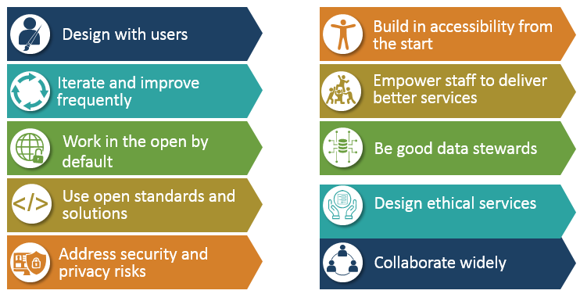
Figure 4: Government of Canada Digital Standards
Source: https://www.canada.ca/en/government/system/digital-government/government-canada-digital-standards.html,

The Standards Information Base captures the standards with which new architectures must comply, which may include industry standards, selected products and services from suppliers, or shared services already deployed within the organization.

EA Repository
The EA Repository is a repository for all the architecture artifacts and deliverables that are captured and developed throughout the lifecycle of an Enterprise Architecture. The purpose of this repository is to provide information describing the current state architecture and a library of reference architectures, models, and principles that describes the target desired state of the architecture, given the business objectives.
In using architecture information to support planning and decision-making, the EA repository is intended to provide a single place for storing and accessing architecture artifacts. Preferably the artifacts are created using EA tools, but some of the artifacts may be custom developed for particular uses. A repository works best if it is easy to access and use, if it is integrated with an EA tool, and if it allows custom developed artifacts to be stored. Additionally, the repository will facilitate configuration management of EA artifacts.
The EA Framework will follow the TOGAF® structural framework for an EA Repository. The data and artifacts that are depicted in the following diagram will also serve as the core target deliverables to define within the initial operating year of the EA Program.
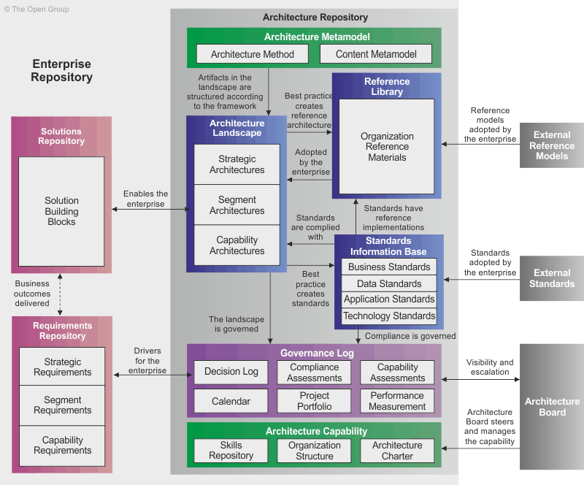
Figure 5: TOGAF Enterprise Architecture Repository Model

Principles
Principles are the highest level guidelines for governance of the enterprise architecture. Principles are general rules and guidelines, intended to be enduring and seldom amended, that inform and support the way in which an organization sets about fulfilling its mission. The level of conformance to the principles will be evaluated for every planned implementation.
The framework will adhere to the enterprise architecture principles conveyed through the Government of Canada Mandatory Architecture Procedures and the principles outlined in the Personal Information Protection and Electronic Documents Act (https://www.priv.gc.ca/en/privacy-topics/privacy-laws-in-canada/the-personal-information-protection-and-electronic-documents-act-pipeda/p_principle/.)

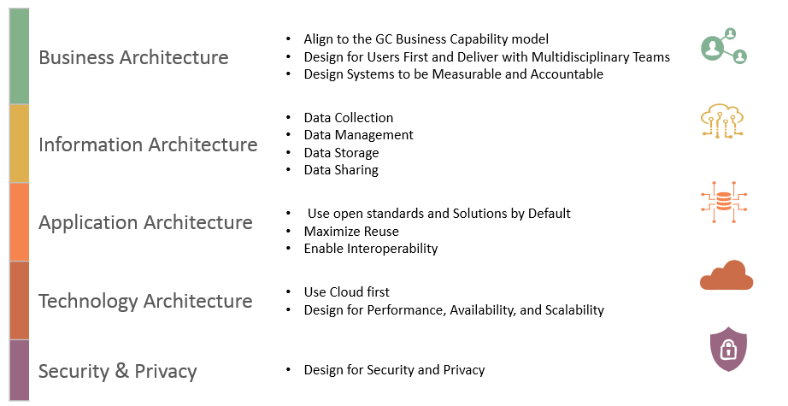
Figure 6: Government of Canada Mandatory Architecture Procedures
Source: https://www.tbs-sct.gc.ca/pol/doc-eng.aspx?id=15249&section=procedure&p=C

People
The people associated with the EAF are the teams and individuals who are chartered with enterprise architecture responsibilities from several perspectives–architecture development, maintenance, implementation, and governance.

Governance
Enterprise Architecture governance provides the structure and processes for implementing an organization’s businesses strategy and objectives through an Enterprise Architecture. An EA governance body is used to guide investment alignment toward the strategic target state for the enterprise. An EA governance model includes:
- People - Teams, individuals, roles, and responsibilities of the governance board(s)
- Processes and Policies - Architecture lifecycle management, change management, review cycles
- Technology - Infrastructure for implementing the processes and policies of enterprise architecture governance
- Financial - Business and IT cost allocation, project-funding models, business case tools to continuously monitor a positive return on investment
- The Reference Library provides guidelines, templates, patterns, and other forms of reference material that can be leveraged in order to accelerate the creation of new architectures for the enterprise.
- The Governance Log provides a record of governance activity across the enterprise
The Government of Canada Enterprise Architecture Review Board (GC EARB) will serve as a key architectural governance body for NextGen HR & PAY, and Treasury Board will serve as a key investment governance body.

Governance Aspects
Enterprise Architecture affects the whole of NextGen HR & PAY’s functions, therefore it is vital that governance functions are carried throughout the complete EA lifecycle. EA governance covers five areas: program management, change management, capability management, policy management and performance management.
It is important to note that these five management areas have to be planned and executed together rather than in a linear fashion. Details of these governance aspects are described below.
- Program Management
The EA will be a continuous journey with dynamic changes affecting different parts of the architectures and reference models. The EA also recommends initiatives that require time to develop and be fully implemented.
- Change Management
Treasury Board Secretariat has already been organizing, planning and executing both business and IT projects. The introduction of EA for NextGen HR & PAY requires changes, such as: organizational reviews, integrated & strategic planning, and making decisions on transformation projects in a structured and timely way. Therefore, change management is necessary for the success of the EA execution.
- Capability Management
Not only does EA require organizational change, but it also requires commitment of NextGen HR & PAY leadership to continuously improve its capability – i.e. the executing of work, improving skills & experiences in architecting, improving business processes & automation, and in integrated planning & decision-making.
- Policy Management
In the development of the EA, NextGen HR & PAY teams may find it difficult to identify things as a standard or a guideline. While this is normal, the EA execution requires policies and regulations to ensure an enterprise-wide standardization and adoption of the various architectures / reference models.
- Performance Management
As a strategic enabler, EA provides the ability to define and measure performance of the enterprise. While this can be accounted for within the Performance Architecture, the execution of EA requires performance metrics to be defined so that management knows whether the EA adoption and implementation itself has been a success.

Organizational Model
In order for an architecture framework to be used successfully, it must be supported by the correct organization, roles, and responsibilities within the enterprise. Of particular importance is the definition of boundaries between different enterprise architecture practitioners and the governance relationships that span across these boundaries.
A typical architecture team undertaking the development of an enterprise architecture as described in TOGAF® would comprise the following roles:
- Architecture Board Members
- Architecture Sponsor
- Architecture Manager
- Architects for:
  - Enterprise Architecture
  - Business Architecture
  - Data Architecture
  - Application Architecture
  - Technology Architecture
  - Security Architecture
- Program and/or Project Managers
- IT Designer

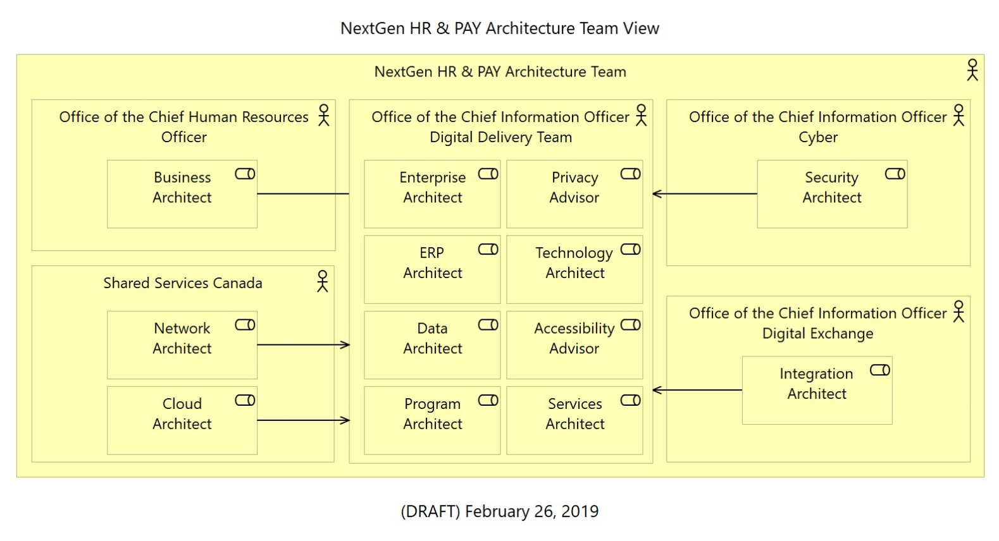
Figure 7: NextGen HR & PAY Architecture Team Model

The Enterprise Architecture Program will follow the TOGAF® Architecture Skills Framework outlined at http://pubs.opengroup.org/architecture/TOGAF®9-doc/arch/chap52.html to define the roles, skills and competencies that NextGen HR & PAY team members will possess.

Services Catalogue
EA is a management discipline that must be managed as a service in order to make it more effective for NextGen HR & PAY. Therefore, the services provided by NextGen HR & PAY enterprise architects must be made visible and accessible to all of its business units. The services will be communicated through existing collaboration tools. The core EA services will be: support for NextGen HR & PAY strategy, architecture development, leadership of an EA program, and support for architecture governance and communication management.
The recommended capabilities for the NextGen HR & PAY EA team to anticipate providing are identified in the following diagram. The set of existing capabilities and priority needs within NextGen HR & PAY will determine if all or a sub-set of the EA capabilities are required.
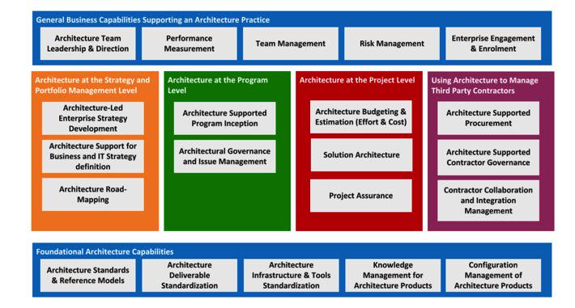
Figure 8: Enterprise Architecture Team Capability Model

Communication
The EA function will expose its activities as a limited set of services designed for transparency and ease of consumption by its target audience(s). Since enterprise architecture integrates with all management functions it is important to establish a communication channel with the key stakeholders that influence the need for architecture.

Process
A selection and adherence to a set of architectural processes that are tailored to guide an architecture engagement through a path that maximizes the chance of a successful implementation and minimizing resource expenditure.

Architecture Method
The following diagram illustrates the architecture process, based on the TOGAF Architecture Development Method (ADM), the activities within it and the major inputs and outputs.
Figure 9: Enterprise Architecture Method

The Architecture Method covers architecture work at the enterprise level as well as at the project or solution level. The following diagram maps it to the Prince II Project Management Process, the ISO/IEC 15288 standard for Systems Lifecycle Processes and ITIL. While the project life cycle, of course, ends with system go-live, the other processes shown in the diagram must continue for the entire life cycle of the system. ISO/TEC 15288 is a generic system life cycle model used in many industries and is not limited to IT. It provides explicitly for system Retirement which is covered by Architecture Change Management (TOGAF) and Service Operation (ITIL).
Figure 10: Architecture Method linking project management, architecture management and IT service management
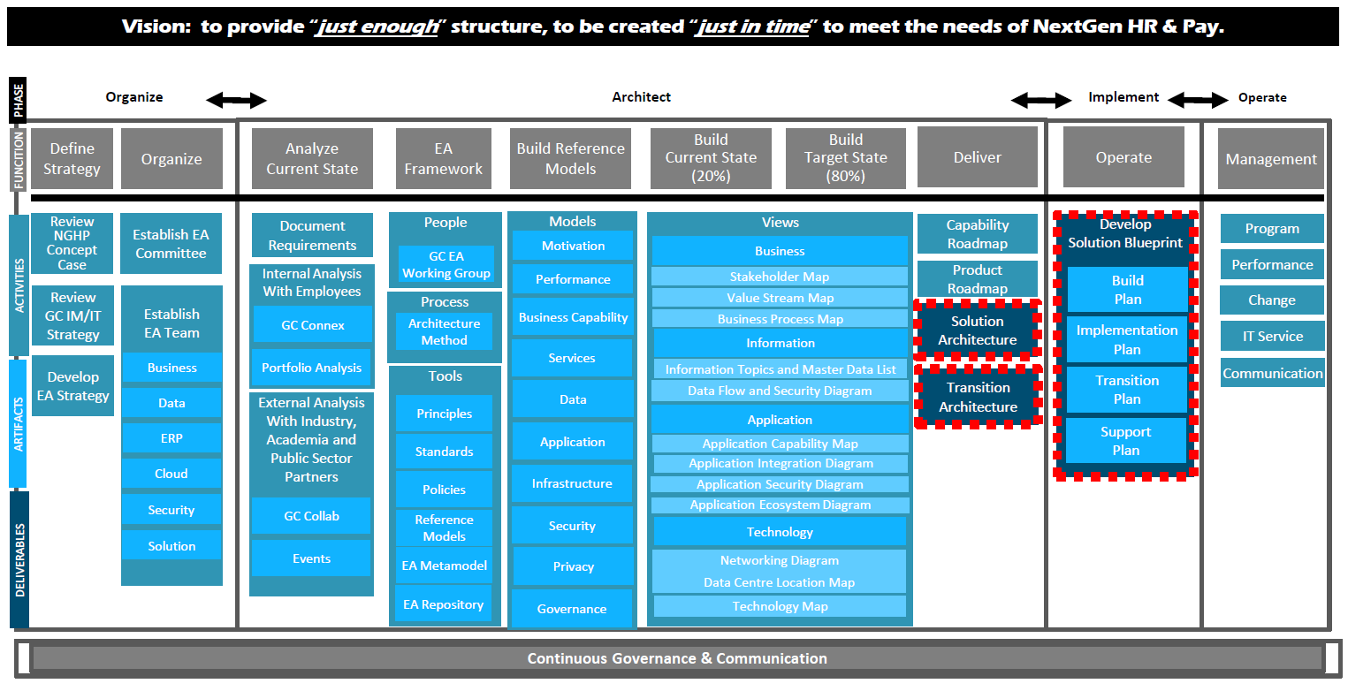
Figure 11: NextGen HR & PAY Architecture Delivery Approach

Reference Architectures
Reference Architectures (RAs) are the means through which the NextGen HR & PAY Enterprise Architecture Framework provides best-practice-based architectural solutions to build common business and/or technical capabilities. RAs facilitate repeatable solutions leading to shared solutions. They also provide a key mechanism to prevent unchecked acceptance of too many different solutions, dilution of the talent pool, challenges in the ability to leverage solutions across business units, and increasing support and maintenance costs. RAs are described in separate documents which are, or will be, made available through the enterprise EA standards publication process.

Current State Architecture
The current state architecture views represent the current state or baseline for the enterprise and consist of the following models:
- Current Business Architecture – it describes the current state business capabilities and the business process model
- Current Information Architecture – it describes the structure of an organization's existing logical and physical data assets and data management resources supporting the business processes
- Current Applications Architecture – it describes what applications are in place to manage the information and support the business processes including their key components and interactions
- Current Technology Architecture – it describes what logical software and hardware capabilities and what networks providing communication paths are in place to support the business, information, and application services additionally, current state architecture views also represent the motivational elements pertaining to the current state as (identified) assessments, requirements, and constraints. The type and depth of documentation of the above models should be guided by the need for detail and answers to questions about requirements, benefits, alternatives, applicable standards, and available resources while making sure that the EA focus is on business outcomes and is not diverted to documentation.

Target State Architecture
The future state architecture views represent the future state (or "to be built" state) of the enterprise within the context of the strategic direction and the operating model and consist of the following models:
- Future Business Architecture – it describes the future state business capabilities and the business process model
- Future Information Architecture – it describes the structure of an organization's logical and physical data assets and data management resources required to support the future state business process model
- Future Applications Architecture – it describes what application systems are necessary and relevant to the enterprise and how those multiple applications work together to support the future state business process model and manage the information
- Future Technology Architecture – it describes what logical software and hardware capabilities and what networks providing communication paths will be necessary and relevant to the enterprise to support the future state business process model, information, and application services Additionally, future state architecture views also identify the motivational elements pertaining to the future state and relate them to other architecture elements.
The type and depth of documentation of the above models will be guided by the need for detail and answers to questions about objectives, requirements, applicable standards, timeframes, and resources.

Roadmap
An enterprise architecture roadmap is represented by a series of transformation projects, each with clearly defined objectives and scope, laid out in a specific sequence in which the projects need to be executed, to reach the target enterprise architecture and thus progressively achieve desired business outcomes. These details are what constitutes an enterprise roadmap or a sequencing plan. This enterprise roadmap is also a key component of an enterprise’s strategic information asset base contained in the EA repository.
While the target architecture may or may not be fully implemented by an organization, every change or a transformation project should be undertaken by the organization in accordance with the enterprise roadmap, to make sure that the changes and transformation projects contribute to improved efficiency, effectiveness, quality and agility.

Operating Model
The Enterprise Operating Model is the conceptual representation of how the enterprise executes its broad functions to achieve its stated purpose. It is the necessary level of business process integration and standardization in a given organization. Based on the necessary level of business process integration and standardization, an organization’s Operating Model falls into one of the four Operating Models illustrated in the diagram below. The Operating Model of the organization drives the target enterprise architecture. It is also the Operating Model that influences which Reference Architectures are applicable in a given context and to what degree. For example, in a Diversification Operating Model, there is very little need to share data; in such a case, a solution such as an enterprise-level Master Data Management serves very little purpose. Taking into account this aspect of the organization - as captured in the applicable Operating Model - is vital for creating viable target enterprise architecture.
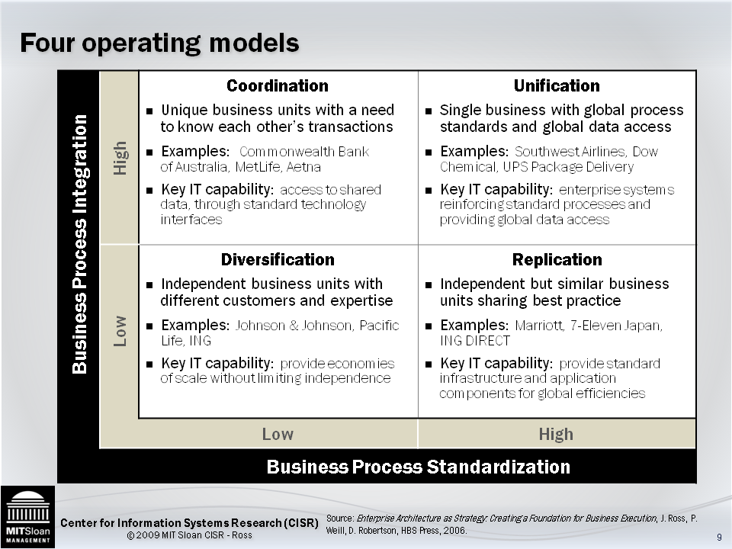
Figure 12: MIT Enterprise Operating Model
It is possible for the same enterprise to have more than one operating model to support different needs. For example, a global firm that has a presence in Europe, Africa and Australia may have each of its individual units follow a replication model due to the restrictive regulations enforced by several countries and the needs of the local demographic. The parent company could follow a coordination model to ensure viability of the organization’s business model to investors.

Tools
The tools element of the EAF are a set of tools and technologies that accelerate the process of developing and managing enterprise architecture. Most of these tools fall under the category of modeling, portfolio management, maturity models, and architecture repositories.

Metamodel
A metamodel identifies the core concepts, relationships between each concept, and the rules to generate additional models. It is the highest level of abstraction and is the starting point for decomposing additional models to address specific stakeholder concerns. The following diagram depicts the NextGen HR & PAY metamodel. The metamodel concepts are overlayed with groupings to represent the common interrogatives – Who, What, When, Where and Why. This means that the enterprise architecture and its decompositions are anchored in this metamodel view and questions pertaining to motivation, strategy, business, information, application, technology, security and privacy can be generated by referencing the available architecture elements.
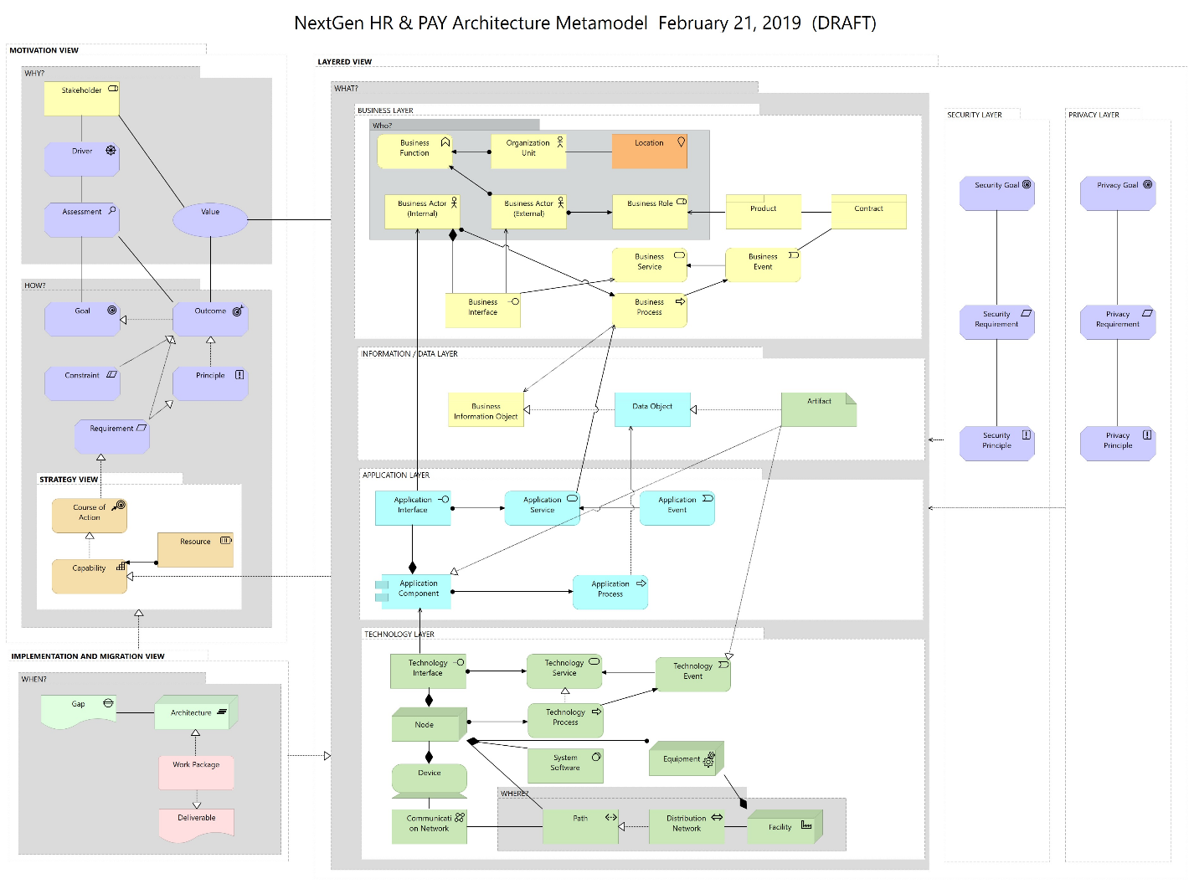
Figure 13: NextGen HR & PAY Metamodel
Each domain represents a specific area of the overall enterprise architecture. These domains delineate the analysis and modeling necessary to meet stakeholder requirements. They serve to help understand how IT assets directly enable business processes and how those processes execute the organization’s mission. Additionally, they allow further analysis to be performed from a top-down or a bottom-up perspective.
This metamodel is based upon ArchiMate 3.0 and it is used to describing and classifying architecturally significant changes to the enterprise. Using this metamodel to develop current and future views of enterprise architecture allows organizations currently using other frameworks to maintain compatibility with their own frameworks, while enabling organizations to visually represent their enterprise architectures for faster modeling and better communication. Additionally, adoption of the metamodel promotes consistent views within and between architectures and promotes interoperability within and between businesses units to initially model their architectures with a few components and then expand over time based on the need for additional detail. For example, in the technology architecture domain, the infrastructure service, infrastructure function and infrastructure interface can be ignored during initial architecture development efforts (thus mapping an application component or artifact directly to a node) but these elements can be added later when that level of detail is required for communication and/or decision-making.
The metamodel can be seen as a top-level reference model for NextGen HR & PAY since all subsequent views and reference models are simply extensions or further elaborations on key areas of focus. This approach allows NextGen HR & PAY to further engage Government of Canada organizational units in enterprise architecture collaboration. The reference models will be further outlined in later sections of this document to show their linkage to TOGAF® and the enterprise architecture repository.

Architecture Views

ERP Strategy View
The ERP Strategy View associates the Government of Canada Enterprise Resource Planning Strategy as being influenced by several internal and external factors; such as: Government of Canada organizational needs, existing policies and principles, industry best practices, and information gained through the delivery of pilots.
The ERP Strategy View’s purpose is to communicate its role in defining the NextGen HR & PAY target state architecture in collaboration with industry and Government of Canada peers.
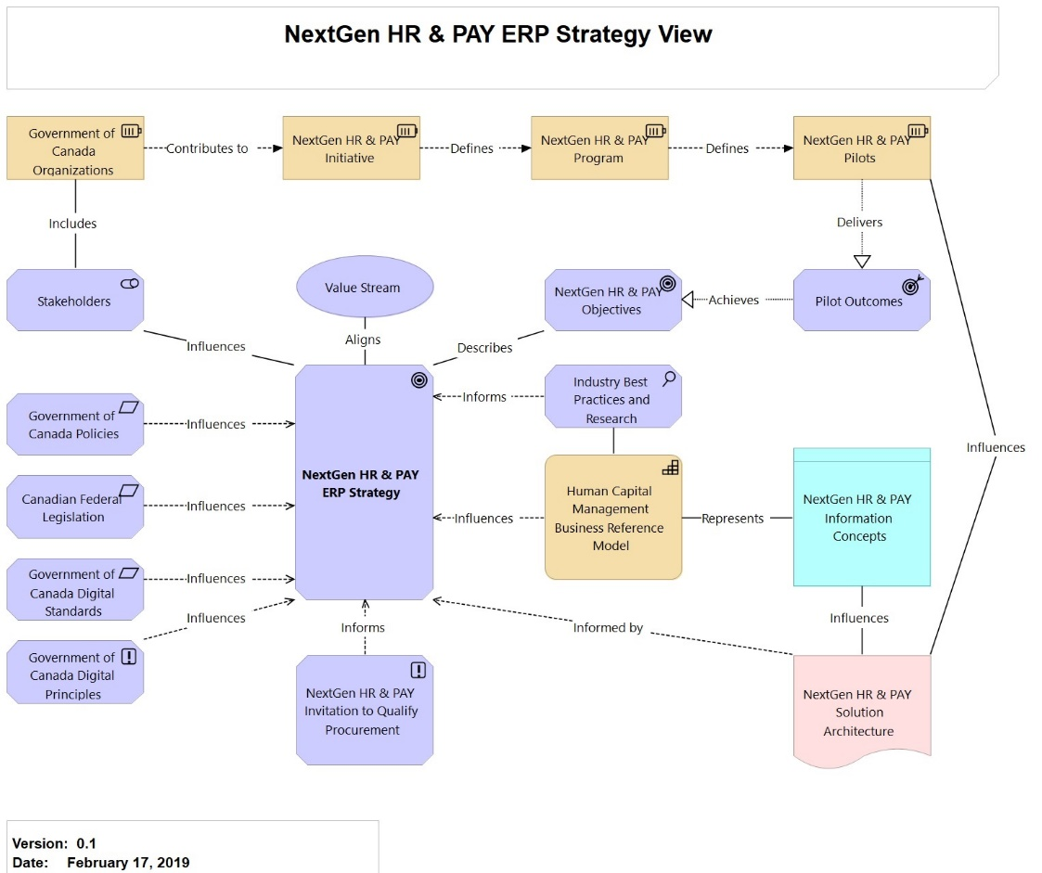
Figure 14: NextGen HR & PAY ERP Strategy View

Motivation View
The Motivation View models the motivation aspect and can be used to present an overview of the relationship between stakeholders, their primary goals, the principles that are applied, and the main requirements on services, processes, applications, and objects.
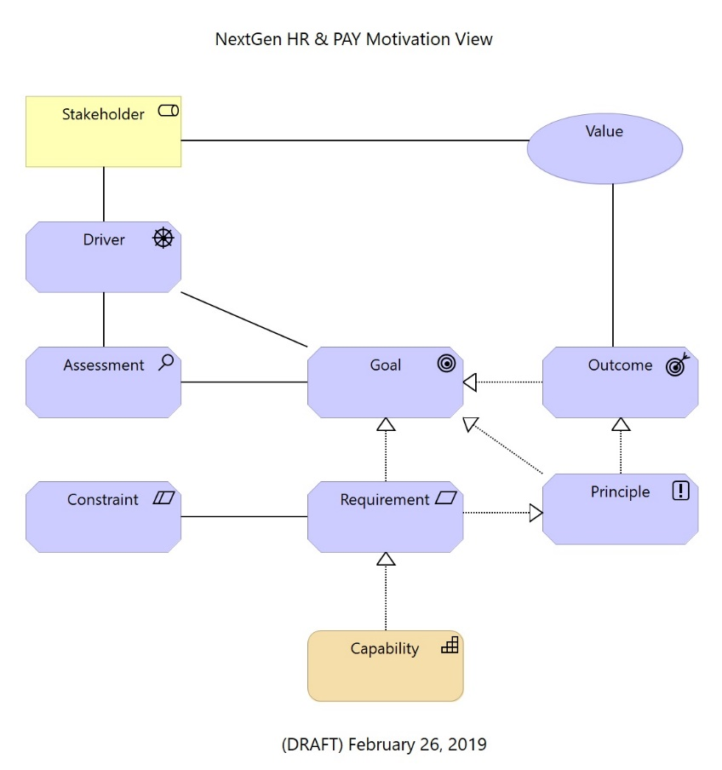
Figure 15: NextGen HR & PAY Motivation View

Privacy View
The Privacy View decomposes the NextGen HR & PAY solution into its Infrastructure-as-a-Service, Software-as-a-Service elements being provided by a 3rd party partner. It also shows the support function being delivered by an additional entity that must also adhere to privacy requirements which are driven by the existing Privacy Act and privacy principles. The view also reflects that there will business data, application data and system data that must all be considered when designing the solution architecture.
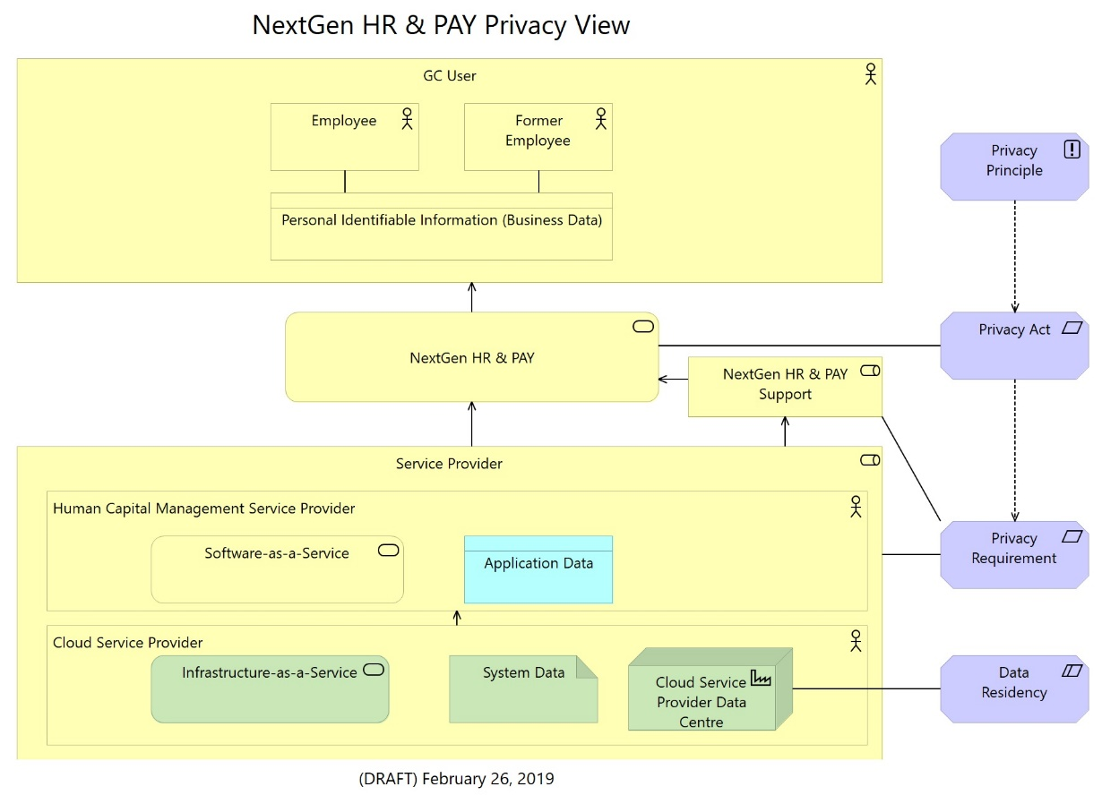
Figure 16: NextGen HR & PAY Privacy View

Governance View
The Governance View guides in establishing an institutional structure for the development, management and maintenance of Enterprise Architecture and its artefacts. The view also defines the processes and structural relationships to ensure that the architecture is consistent with the business vision and objectives of the enterprise and is implemented in strict compliance with the architectures developed.
The following are the benefits of the Governance View:
  - It ensures that the proposed architecture meets the overall vision and objectives of the Government.
  - It facilitates clear and quick decision-making on complex issues by bringing in transparency and accountability.
  - It brings clarity in roles and responsibilities through management oversight.
  - It preserves architectural coherence by weaving in a compliance culture.
  - It keeps architecture relevant and useful in a pragmatic manner.
  - It promotes architecture thinking in NextGen HR & PAY
The Governance View elements are represented by the following diagram.
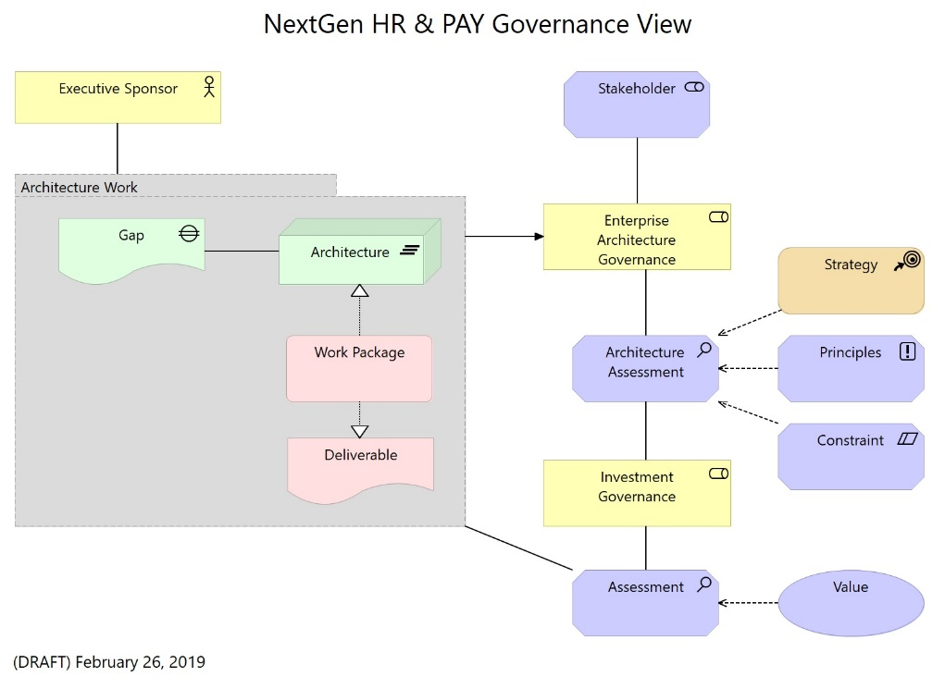
Figure 17: NextGen HR & PAY Governance View

Reference Models
The structure of the NextGen HR & PAY EA Framework consists of a number of Reference Models, each dealing with a specific domain of the Enterprise Architecture. A Reference Model is an abstract representation of the entities relevant to a domain of the Enterprise Architecture, the inter-relationships among those entities, and the standards to be followed. The representation is both visual and textual thereby specifying the capabilities of each of the components (entities) comprising the Reference Model. Each Reference Model also contains the list of standards that should govern the entities, their relationships and the manner of communications between them. The majority of the Reference Models comprising NextGen HR & PAY EA are technology agnostic. These Reference Models are, by definition, devoid of the details specific to their implementation.
Through a combination of the above-stated three basic attributes of all the Reference Models, namely, abstraction, standards-base and technology-neutrality, the NextGen HR & PAY EA Framework is sufficiently generic for its widespread adoption by various Government of Canada lines of business.
The reference models will consistently enable architects to holistically describe architectures from a standardized top-down business driven approach and a bottom-up technology focus. Additional architecture views can be created using ArchiMate as the common modelling notation and focusing on elaborating upon the NextGen HR & PAY metamodel.

Using Reference Models to Create Business Value
Reference models can be a driving force to generate business value for NextGen HR & PAY. The following seven analysis techniques will be supported by the reference models contained within the NextGen HR & PAY EA Framework. Several of these and other analyses can be combined in multi-level metrics that provide business-focused information on the make-up and health of NextGen HR & PAY’s IT landscape. This is useful input for application and project portfolio management, and for prioritizing and planning the requisite changes.
- Impact Analysis - Impact analysis that traverse the structure of the models to assess, for example, the business importance of applications, the contribution of change initiatives to strategic objectives, or the enterprise-wide effects of changes.
- Dependency Analysis - Dependency analysis that explore the coherence between architecture elements. Identifying the critical elements of the architecture, areas of risks, and bottlenecks.
- Process Analysis - Process analysis that look at the efficiency of business processes. Identifying the critical paths in processes and areas to improve the throughput.
- Lifecycle Analysis - Lifecycle analysis to address the evolution of the enterprise over time. Planning change initiatives and controlling the lifecycle of the elements in the architecture landscape, taking care of dependencies, the processes and systems they realize or change, and the desired business outcomes.
- Business Analysis - Business value and technical value analysis for application portfolio management. Assessing the importance of an application for NextGen HR & PAY, and how well it does its job.
- Financial Analysis – Identifying where the enterprise is spending its money and if investments are aligned with business goals.
- Governance, Risk, Compliance (GRC) Analysis - Risk, security and compliance analysis, for example in the context of regulatory compliance, privacy and cyber security.
The NextGen HR & PAY EA Framework is comprised of a series of Reference Models, represented below. The models serve as an elaboration of the metamodel and reinforce the ontology classification structure to link the enterprise across distinct domains. In addition to the four dimensions that TOGAF deals with, namely, Business, Information, Application, and Technology, the NextGen HR & PAY EA Framework consists of three more Reference Models, namely, Performance, Security, and Infrastructure.
The NextGen HR & PAY EA metamodel is the highest-level guiding architecture artifact and it serves as the "model of models" where each reference model is represented. The reference models can be used to inventory or list the current state architecture elements but the true business value of the reference models is obtained when the models are used to assess the potential impacts of change and gaps between the current and target states for each model.

Performance Reference Model
The Performance Reference Model (PRM) is an outcome-focused measurement framework that can assist NextGen HR & PAY in the design and implementation of effective business measurement systems and performance architectures. The PRM, through the measurement indicators, sets the performance standards for NextGen HR & PAY. Hence, from an architectural viewpoint, the PRM sets the performance standards for the other reference models.
The PRM is in support of the Departmental Results Framework and the Directive on Results (http://www.tbs-sct.gc.ca/pol/doc-eng.aspx?id=31306&p=A&section=procedure).
The elements of the PRM are:
- Measurement Areas
- Measurement Categories
- Measurement Groupings
- Measurement Indicators
The following are the benefits of the PRM:
- Enterprise Architecture is NOT about making a better Architecture but is about making a better Enterprise. This translates to the need for the EA effort to drive the efforts of the organization to a better performance.
- Potential cost reduction due to standardization and re-use.
- Cost avoidance due to procuring only the required ‘just in time’ and ‘just enough’ investments to meet the forecasted needs.
- Cost savings due to more efficient and effective implementation of the development and delivery of services, and enhanced effectiveness in planning and coordination due to availability of right information to the right people at the right time.

Business Capability Model
A business capability is the ability of an enterprise to deliver products or services to clients or customers. The Business Capability Model (BCM) is a representation of the business capabilities that are desired to support NextGen HR & PAY. The BCM focuses on describing ‘what abilities’ are in-scope at the strategic, core and enabling levels for NextGen HR & PAY. The BCM is technology and organizational agnostic by default.
As elaboration occurs during the architecture development process then a business capability can be further defined by its constituent parts. The following figure depicts a business capability further decomposed into its constituent parts and also serves as a linkage back to the NextGen HR & PAY metamodel. The figure also illustrates the distinction between a business capability, business service, business function and a business process.

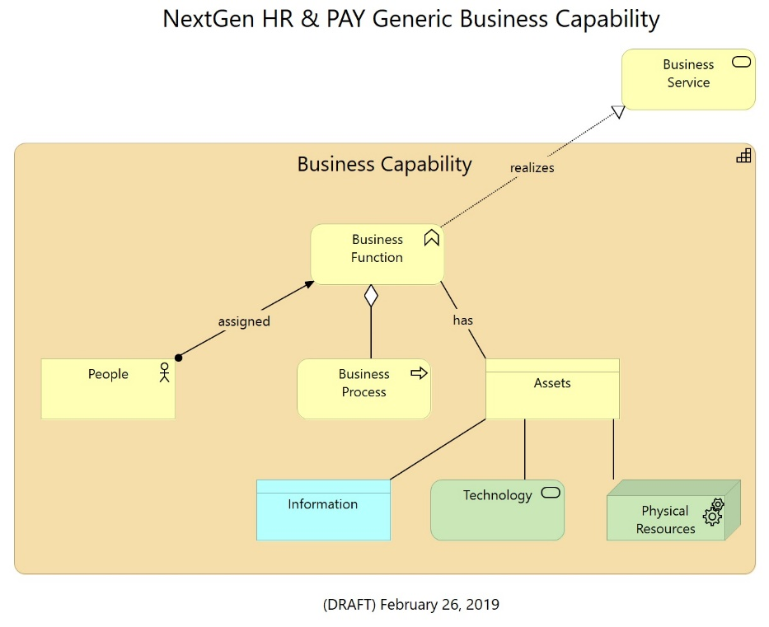
Figure 18: Generic business capability

Business Reference Model
The Business Reference Model (BRM) is a classification category used to describe the type of business functions for the whole of NextGen HR & PAY. It gives a logical functional view instead of functions by physical NextGen HR & PAY business units. The functions and requirements in the BRM drives the other reference models, i.e. Application Reference Model, Data Reference Model and Infrastructure Reference Model. The BRM serves to provide the next level of granularity of the needs for NextGen HR & PAY beyond capabilities.
The elements of the BRM are:
- Business Function
- Business Organisation Unit
- Business Service
- Business Process
The following are the benefits of BRM:
  - Provides the “what we do” view of the enterprise at an aggregated level
  - Improves intra- and inter-business communication and collaboration through a standardized way of identifying higher level business functions and services
  - Allows the operational costs and proposed project costs to be aggregated and mapped to the budget functions

The BRM enables NextGen HR & PAY to communicate:
- What services do we deliver?
- What functions of government do we enable?
- What is our organisational structure?

When the BRM and PRM are considered together then NextGen HR & PAY is now able to communicate:
- How effectively do we deliver services?
- How effective are we in securing outcomes for government?
- Is our structure optimal for our business?

Data Reference Model
The DRM (Data Reference Model) is a model that classifies data and defines a standard data structure to support developing information and data architecture and promoting data standardization, data reuse and data management. It serves as an integrated business view of data produced and consumed across the organization.
The DRM supports the BRM directly in delivering business goals by supplying data and information. The DRM supports interoperability and data flow discussions and identifying the various application systems which have to use data to provide information to the businesses.
The DRM elements are:
- Domain – categorization all data for the enterprise at its highest level (i.e. 10-12 domain areas)
- Subject – the decomposition of the Domains into major business concepts or subjects that represent the data (i.e. 10-12 subjects per domain)
- Topic – the decomposition of the domains and subject areas into detailed entities including key attributes and business relationships (i.e. able to support more than 10-12 topics per subject)
The first iteration of the DRM will focus upon providing authoritative definitions data recorded within the Domain and Subject elements. Future iterations will mature to include mapping to data rules, data classification, linked business processes, data owners, mapped legislation and regulation, and data retention and disposition.
The following are the benefits of DRM:
  - DRM identifies producers and consumers of data
  - DRM can help identify opportunities for data sharing and reuse, and for increasing integration
  - DRM can help identify opportunities for eliminating redundant data collection activities and storage within and across business units
  - Promotes a common business understanding of data
  - Supports data governance and data management
  - Further elaborates upon business reference architecture

Application Reference Model
The Application Reference Model (ARM) is a categorization of different types of application systems, application components and interfaces. It is the framework for categorizing business services by their IT systems and application components to help identify opportunities for sharing, reuse, and consolidation or even renegotiation of software licenses amongst business organizations. The ARM supports directly the BRM in delivering the business outcomes. The ARM is used to set context and drive further modelling efforts in the application layer. The ARM reflects a high level summary of the Government of Canada Application Portfolio Management inventory and serves as the entry point to further describe which business services are mapped to enabling technology, technology standards, selected technology products and components.
A Services Reference Model and a Technology Capability Reference Model will be two additional levels of detail that will be used to further elaborate upon the ARM. The Services Reference Model will be used to outline the management services and functions that are required to support the business services identified in the ARM. The Technology Capabilities Reference Model is an association of the technology component types, which are product agnostic, that are used to define what the technology does in support of the business and application services.
The elements of the ARM are:
- Business Service
- Application Service
- Application Component
- System Software
The following are the benefits of ARM:
  - Facilitates the identification of commonly used application components and services that can be standardized and harvested as reusable assets
  - Allows identification of available application components for reuse or sharing to reduce costs
  - Facilitates faster response to business needs by allowing new applications or extensions to existing applications to be built from pre-existing components
  - Helps reduce risks on projects when proven components are leveraged
  - Helps identify redundant existing or proposed applications and/or their components within a business unit or across the enterprise
  - Reuses existing Government of Canada investments to the Application Portfolio Management process

Infrastructure Reference Model
The Infrastructure Reference Model (IRM) supports architectural analysis and reporting related to the platform, network and facilities to support systems and applications. The IRM advances the reuse and standardization of technology and service components from an enterprise perspective.
The elements of the IRM are:
- Platform
- Network
- Facility
- Location
The following are the benefits of the IRM:
  - Aligning capital investments to the IRM leverages a common, standardized vocabulary, allowing inter-business discovery, collaboration, and interoperability.
  - NextGen HR & PAY and business units will benefit from economies of scale by identifying and reusing the best solutions and technologies for applications that are developed/provided or subscribed to support their business functions, mission, and target architecture.

Security Reference Model
The Security Reference Model (SRM) represents a cross-cutting association to the overall metamodel. The SRM delineates the overall framework’s architecture domains (Business, Information, Application, Technology and Privacy) for providing information security to the entire scope of the enterprise. Integrity, privacy, confidentiality, and availability of information / IT systems are the key concerns addressed by the SRM. SRM adopts a layered approach to identifying and meeting the information security needs of the enterprise.
The elements of the SRM are:
- Security Goal
- Security Requirement
- Security Principle
The following are the benefits of the SRM:
  - The model identifies the security controls to be applied at all layers across the enterprise
  - SRM also touches upon the manner of designing Security Policies and Standard Operating Procedures.
  - Linking security and privacy to NextGen HR & PAY enterprise architecture, including performance objectives, business processes, data flows, applications and infrastructure technologies, ensures that each aspect of the business receives appropriate security and privacy considerations.

Linking Reference Models to TOGAF®
The Reference Models (RMs) are a representation of the insight and information that is required for NextGen HR & PAY Architecture stakeholders to have a holistic view on NextGen HR & PAY investments. The RMs also represent the sub-sections of the NextGen HR & PAY EA metamodel. The concept of using RMs is aligned with an effective enterprise architecture.
The primary objectives of NextGen HR & PAY EA Framework RMs are to:
• Capture, codify and connect architecture elements across the full spectrum of enterprise architecture;
• Kick start enterprise architecture initiatives across NextGen HR & PAY;
• Enrich the procurement planning process;
• Identify issues and concerns concerning NextGen HR & PAY investments;
• Support the NextGen HR & PAY's transition towards data driven decision making a NextGen HR & PAY Target State Architecture.
Simply having availability to the reference models is not enough for NextGen HR & PAY to adopt enterprise architecture. This section elaborates how the reference models can be used in relation to an established enterprise architecture development process. Taking the TOGAF® Architecture Development Methodology (ADM) as the base, each phase is summarized and the use of relevant Reference Models is described. Readers are referred to the detailed objectives, steps, inputs and outputs of the TOGAF® ADM in the main TOGAF® standard. They are not repeated here to maintain brevity.
NextGen HR & PAY enterprise architecture follows a multi-level approach. Business services should be analyzed for inter-organizational linkages, and automation/digitization and infrastructure requirements. Different viewpoints should be linked to ensure a 360-degree view of the customer, businesses and partners of NextGen HR & PAY. Service delivery is to be supported by deep collaboration between lines of business in terms of information flow, application interaction and common infrastructures.
When the broader NextGen HR & PAY leads with an enterprise architecture defined by standards and generally accepted frameworks it then forms an input to individual line of business architectures. This approach ensures that lines of business, while conforming to the overall NextGen HR & PAY enterprise architecture, are still able to retain their autonomy and operational independence, thereby reflecting the defined NextGen HR & PAY governance structure. This approach also enables lines of business, if deemed necessary, to have the flexibility to define their own focused enterprise architectures based on their unique needs.

Preliminary Phase
This purpose of this phase is for NextGen HR & PAY to prepare and get the entire ecosystem ready. As part of this phase, lines of business are recommended to study and understand the Reference Models, their purpose, and implications. It is important to study all of the models and the preparation and information needed to demonstrate conformance.
The Reference models also include architecture principles. This is a good time to revisit the standard principles, and check for their adequacy and make any revision required.
The suggested outputs from this phase include:
• Business Vision and Mission
• Organizational Model
• Architecture Principles
• Architecture Governance Strategy

PHASE A: Architecture Vision
In this phase the architecture project scope, initiation of the architecture development cycle, identification of stakeholders, their concerns, business requirements, business goals, evaluation of business capabilities, target architecture value propositions, architecture principles are performed or established. Within the scope of activities and recommended outputs for this phase, the Performance Reference Model is the primary model to be used. In addition, certain aspects from the Business Reference Model and Governance Reference Model should be used in this phase.
The NextGen HR & PAY EA Framework does not prescribe the overall vision and mission for each one of the individual lines of business. This is deliberate as it is expected that every line of business building its architecture will define its own business vision and mission to suit its priority and direction.
One of the key outputs of this phase is to define the key performance indicators (KPI). The PRM explains the process to define KPIs, provides the most fundamental performance principles and critical measurement dimensions like KPI type, frequency of measurement, actions to be taken in case of deviations. The fundamental purpose of the PRM is to demonstrate that KPIs do positively influence goals and fulfillment of objectives, leading to achievement of vision and mission. The business goals and objectives must be defined as part of realizing the defined mission and vision.

PHASE B: Business Architecture
This phase primarily covers the approach to realize the vision and mission, through the development of business architecture. The validated business principles, business goals and business drivers are critical components of this phase. The business principles are elaborated. The current and target business architectures are developed and documented, gaps between the two perspectives are analyzed for identification of opportunities. These opportunities are then utilized to create high level technical requirements, and the first cut of the architecture roadmap. The BRM is the primary reference in this phase, while the PRM forms the secondary reference. Broad reference to the other reference models are more to understand the impact of business architecture to the technical domains, so that the high level technical requirements can be identified.
The BRM captures the answer to what is the business of NextGen HR & PAY through the listing of business services and organizations that deliver the services to clients, businesses and other stakeholders.
Development of current service catalogue, the process of service prioritization, service rationalization and simplification of service portfolio leading to the creation of target service catalogue is guided by the BRM. The recipients of the services (service beneficiaries) and service outcomes are also covered in the BRM. These form critical components of the target business architecture. The target business architecture is linked to the PRM through the service outcomes impacting the KPIs. The target business architecture is elaborated through the underlying business processes that realize the services, and identify any need for process reengineering. The processes provide input to identify the supporting data requirements and governing business rules, linked to the DRM and other reference models.
A key deliverable from Phase B is the TOGAF® architecture definition document which takes input from the BRM, to a lesser extent from the PRM and GRM, and covering the linkages to the technical domains captured in the other reference models. A preliminary perspective toward the current and target state architectures, if not already defined, can be created during this phase.

PHASE C-1: Data Architecture
This first sub-phase within Phase C of TOGAF® ADM covers data and information aspects. Data is the new currency in the digital world. For NextGen HR & PAY to encourage and support the concept of “one enterprise”, the underlying data is a critical success factor. Through this sub-phase the target is to enable data standards, data definition and data exchange. The first and foremost activity in this phase is to find / discover data that are required and needed, the second is to find a common agreed way to describe the data. Data discovery and description is deeply influenced by business and operations, therefore context is essential for data to be meaningful and usable. As part of defining the data architecture, organizations are advised to build on the architecture principles provided in the DRM.
Defining the current state data architecture should consist of identifying the core applications and systems and subject them to reverse engineering to identify the underlying data entities. These current data entities should be captured together to understand the relationships and interactions. This phase may require NextGen HR & PAY to revisit their existing data assets to ensure that their data inventories are complete, duplication of data is addressed, the context of the data is known, isolated data is made visible, missing links to business services are addressed, and that data governance is defined. In defining the target architecture, the DRM should be used to build meta-data standards, data definition, interoperable data sharing and data context.
Available data dictionaries in various domains (i.e. Finance, HR, and Marketing) should be closely followed and adopted, to avoid creating duplicate data. Data should be a reusable asset that is mission-critical. This should be augmented with strong and effective data governance. The architecture definition document in this sub-phase should cover issues like – who / which process creates the data, how does the data flow, where does it get used, in what format does it get created, who owns the data, who is allowed to modify the data and under what circumstances, which is the single definitive source
for this data.

PHASE C-2: Application Architecture
This second sub-phase within Phase C of TOGAF® ADM covers the IT systems and applications used to realize business capabilities, automate business services and their underlying business processes. The systems and applications are the most visible and utilized portion of the enterprise architecture, as they manifest how interactions take place. The ARM provides specific inputs by way of suggested application architecture principles. The current application architecture is developed and analyzed. The most important observable characteristic in the context is that applications in the NextGen HR & PAY machinery usually reflect any fragmented or stovepiped thinking that exists in the business operations. The most important part of using the ARM to build the target application architecture is to analyze the application catalogue and identify application capabilities as part of the Application Portfolio Management activities. The ARM classifies applications as core, common, group and departmental applications. Reorganizing applications through a process of decomposing, understanding, rationalizing and consolidating is a critical part of the developing the target application architecture.
The suggested outputs from this phase are:
• Current State Application Architecture
• Target State Application Architecture
• Gaps and Opportunities Analysis Report
• Application Portfolio Management inventory
• Application Development Strategy
• Application Integration Architecture

PHASE D: Technology Architecture
In this phase, the technology infrastructure aspects are covered. The role of IRM in this phase is crucial, and this is the architecture layer that benefits the most from standardization. The IRM identifies the technology categories, domains and relevant applicable standards. Usually, due to procurement and adoption of technology at different times and by different people results in technology diversity and technical debt for NextGen HR & PAY. When analyzing the current technology architecture and developing the target technology architecture, institutions should refer to the IRM which covers says to structure the technology layer, provides guidance on technology standards and their applicability, factoring in the enterprise’s priorities and preferences (i.e. use of Open Source, and Cloud First).
The suggested outputs from this phase are:
• Current State Technology Architecture
• Target State Technology Architecture
• Gaps and Opportunities Analysis Report
• Technology Bricks
• Technology Modernization Strategy
• Security Technologies Catalogue

ADDITIONAL PHASE: Security Architecture
This is not a separate phase in TOGAF® ADM, usually the security aspects being implicit and subsumed within Phases B, C and D. The NextGen HR & PAY Enterprise Security Architecture Framework (located at ....) is the authoritative source to reference and further defines how to align the Security Architecture to the NextGen HR & PAY EA Framework.
Developing the security architecture (the target state view) should start with defining security architecture principles. The layers identified in the SRM should be used for the current state analysis which lists the portfolio of security controls. The controls are applied over the different architecture layers of data, application, interoperability and technology.

PHASES E & F: Opportunities & Solutions and Migration Planning
The usage of the reference models in the other TOGAF® phases generates the gap and opportunity analysis that can be leveraged within this phase. This is attributable to the fact that, in general, reference models are extensively used during architecture conceptualization, architecture elaboration and architecture governance. It is also useful for architecture evaluation.
The suggested outputs from these phases are:
• Consolidated Gaps and Opportunities Analysis Report
• Consolidated Target State Architecture Description
• Architecture Roadmap

PHASES G, H & Requirements Management
After the creation of the Architecture Roadmap, Phase G of ADM covers activities required for implementation governance. The GRM is the primary reference to be used in this phase. The GRM provides guidance on the mode of governance, and mechanisms to ensure that the decision rights and accountabilities are clear and assigned to the right stakeholders. These should be part of the architecture governance strategy. Success of the enterprise architecture stems from the fact that the roadmap is adopted.
EA can be used for activities such as strategy execution, business capability management, or even IT investment decisions. The details of how EA can used, should be elaborated in the architecture adoption plan. Phase H, architecture change management is where steps are taken to ensure that – changes are managed in a structured manner during implementation and that the reference models and architectures are kept updated by incorporating a process of periodic refresh.
There is no specific reference model supporting this activity and general knowledge of all reference models is recommended. As lines of business and other “consuming” entities start building and implementing their architectures, these provide inputs to add to and enrich the reference models. This feedback process should be formalized and internalized, in order to close the loop.
Development of the compliance process and items are informed by all the reference models. The reference models should be built into an EA tool in order to enable automating the administration and management of architecture activities.
The suggested outputs from these phases include:
• Architecture Governance Strategy
• Architecture Adoption Plan
• Architecture Management Plan
• Architecture Compliance Checklist and Process
• Requirements Management Approach and Plan

ADDITIONAL PHASE: Conceptual Solution Architecture
This is an additional phase which extends the standard TOGAF® ADM. The need for this phase is driven by four factors:
• Defining the linkage of enterprise architecture to solution architecture;
• Building the capabilities to realize the target state architecture;
• Providing an integrated view of the business capabilities, business services, data, systems and technology architectures in a visible way; and
• Enabling and enriching the procurement planning process.
Guided by the priorities elaborated in the target state enterprise architecture and the overall business vision and mission, the development of the conceptual solution architecture initiates with the
assessment of current business services, data, and systems to determine the business value and overall alignment to business goals and objectives. The requirements for the target capabilities and services are derived in a way that conforms to the target enterprise architecture. In developing target solution architecture, the reusable components (from the various reference models) should be used. This should also include understanding the dependencies, constraints, risks and issues in getting the architecture components to work together in a coherent fashion. Capabilities that are not covered in the reference models, should be defined as reusable components, and as part of the institutional governance process can becomes candidates to be included in the next update of the NextGen HR & PAY EA Framework. The NextGen HR & PAY Enterprise Architecture Council, which is comprised of Treasury Board Secretariat Office of the Chief Information Officer, Office of the Chief Human Resources Officer, Shared Services Canada and contributing areas within NextGen HR & PAY, will be the initial reviewing forum for any proposed changes to the RMs. The outputs from this phase should be vendor and technology agnostic.
The suggested outputs from this phase are:
• Current Conceptual Solution Architecture
• Target Conceptual Solution Architecture
• Target Deployment Strategy and Architecture
• Solution Transition Roadmap

Maturity Model
The TOGAF based enterprise architecture maturity model provides a means to measure the level of maturity for the practice of enterprise architecture. It can be used to inform the practitioner on what they must change in order to further improve their competencies and capabilities pertaining to enterprise architecture.
The benefits of a maturity model include:
- They describe the practices that any organization must perform in order to improve its processes.
- They provide a yardstick against which to periodically measure improvement.
- They constitute a proven framework within which to manage the improvement efforts.

Level 0: None
No Enterprise Architecture program. No Enterprise Architecture to speak of.

Level 1: Initial
Informal Enterprise Architecture process underway.
- Processes are ad hoc and localized. Some Enterprise Architecture processes are defined. There is no unified architecture process across technologies or business processes. Success depends on individual efforts.
- Enterprise Architecture processes, documentation, and standards are established by a variety of ad hoc means and are localized or informal.
- Minimal, or implicit linkage to business strategies or business drivers.
- Limited management team awareness or involvement in the architecture process.
- Limited operating unit acceptance of the Enterprise Architecture process.
- The latest version of the operating unit's Enterprise Architecture documentation is on the web. Little communication exists about the Enterprise Architecture process and possible process improvements.
- IT security considerations are ad hoc and localized.
- No explicit governance of architectural standards.
- Little or no involvement of strategic planning and acquisition personnel in the Enterprise Architecture process. Little or no adherence to existing standards.

Level 2: Under Development
Enterprise Architecture process is under development.
- Basic Enterprise Architecture process is documented. The architecture process has developed clear roles and responsibilities.
- IT vision, principles, business linkages, Baseline, and Target Architecture are identified. Architecture standards exist, but not necessarily linked to Target Architecture. Technical Reference Model (TRM) and Standards Profile framework established.
- Explicit linkage to business strategies.
- Management awareness of architecture effort.
- Responsibilities are assigned and work is underway.
- The operating unit Enterprise Architecture web pages are updated periodically and are used to document architecture deliverables.
- IT security architecture has defined clear roles and responsibilities.
- Governance of a few architectural standards and some adherence to existing Standards Profile.
- Little or no formal governance of IT investment and acquisition strategy. Operating unit demonstrates some adherence to existing Standards Profile.

Level 3: Defined
Defined Enterprise Architecture including detailed written procedures and TRM.
- The architecture is well defined and communicated to IT staff and business management with operating unit IT responsibilities. The process is largely followed.
- Gap analysis and Migration Plan are completed. Fully developed TRM and Standards Profile. IT goals and methods are identified.
- Enterprise Architecture is integrated with capital planning and investment control.
- Senior management team aware of and supportive of the enterprise-wide architecture process. Management actively supports architectural standards.
- Most elements of operating unit show acceptance of or are actively participating in the Enterprise Architecture process.
- Architecture documents updated regularly on Enterprise Architecture web page.
- IT security architecture Standards Profile is fully developed and is integrated with Enterprise Architecture.
- Explicit documented governance of majority of IT investments.
- IT acquisition strategy exists and includes compliance measures to IT Enterprise Architecture. Cost benefits are considered in identifying projects.

Level 4: Managed
Managed and measured Enterprise Architecture process.
- Enterprise Architecture process is part of the culture. Quality metrics associated with the architecture process are captured.
- Enterprise Architecture documentation is updated on a regular cycle to reflect the updated Enterprise Architecture. Business, Data, Application, and Technology Architectures defined by appropriate de jure and de facto standards.
- Capital planning and investment control are adjusted based on the feedback received and lessons learned from updated Enterprise Architecture. Periodic re-examination of business drivers.
- Senior management team directly involved in the architecture review process.
- The entire operating unit accepts and actively participates in the Enterprise Architecture process.
- Architecture documents are updated regularly, and frequently reviewed for latest architecture developments/standards.
- Performance metrics associated with IT security architecture are captured.
- Explicit governance of all IT investments. Formal processes for managing variances feed back into Enterprise Architecture.
- All planned IT acquisitions and purchases are guided and governed by the Enterprise Architecture.

Level 5: Measured
Continuous improvement of Enterprise Architecture process.
- Concerted efforts to optimize and continuously improve architecture process.
- A standards and waivers process is used to improve architecture development process.
- Architecture process metrics are used to optimize and drive business linkages. Business involved in the continuous process improvements of Enterprise Architecture.
- Senior management involvement in optimizing process improvements in architecture development and governance.
- Feedback on architecture process from all operating unit elements is used to drive architecture process improvements.
- Architecture documents are used by every decision-maker in the organization for every IT-related business decision.
- Feedback from IT security architecture metrics are used to drive architecture process improvements.
- Explicit governance of all IT investments. A standards and waivers process is used to make governance-process improvements.
- No unplanned IT investment or acquisition activity.
Source: https://pubs.opengroup.org/architecture/togaf9-doc/arch/chap45.html#tag_45_03

Architecture Domains
Domains: The architecture domains of Business, Information, Application, Technology, Security and Privacy serve to emphasize that strategic goals drive business capabilities, which in turn provide the requirements for enabling business processes, information, application systems and technologies. Security and Privacy architecture are integrated into all of the domains.

Business Architecture Domain
Any architectural discussion should begin with Business Architecture. The Business Architecture aligns an organization’s operating model, strategies, and objectives with IT; it also creates a business case for IT transformations and provides a business-centric view of the enterprise from a functional perspective. Business capabilities are a more powerful organizing structure for driving a consistent approach to the common and future objectives of the enterprise, while managing for fundamentally different concurrent business.
This part of the framework provides the following three key areas of information about the business:
- Business Strategy: Key business requirements, objectives, strategies, key performance indicators, business risks, and the business-operating model (how processes and systems are centralized versus decentralized across the business).
- Business Function: The key business services, processes, and capabilities that will be affected by the enterprise architecture effort.
- Business Organization: The high-level nature of the organizational structures, business roles (internal audiences, external customers and partners), the decision-making process, and the organizational budget information

Information Architecture Domain
The Information Architecture describes all of the moving pieces and parts for managing information across the enterprise, and the sharing of that information to the right people at the right time to realize the business objectives stated in the business architecture.
The key components for describing the information architecture are:
- Information Strategy: The information architecture principles, information governance and compliance requirements, canonical data models, and industry data model support strategy and a set of reference information exchange as well as dissemination patterns and reference models.
- Information Assets: A catalog of critical business data types and models (such as customer profile, purchase order, product data, supply chain, etc.) and the relationships between those business data types and all the services and processes that interact with that data.
The Information Architecture provides an information- and data-centric view of an organization, focusing on key information assets that are used to support critical business functions.

Application Architecture Domain
The Application Architecture provides an application- and services-centric view of an organization that ties business functions and services to application processes and services to application components in alignment with the application strategy. The Application Architecture’s scope, strategy, standards are a consequence of the Business Architecture.
The Application Architecture is composed of the following content categories:
- Application Strategy: The key application architecture principles (Build versus Buy, Hosted versus In-House, Open Standards versus .NET, etc.), application governance and portfolio management, and a set of reference application architectures relevant to the customer.
- Application Services: An inventory of the key application services exposed to internal and external audiences that support the business services.
- Application Processes: A series of application-specific processes that support the business processes in the Business Architecture.
- Logical Components: An inventory of the relevant product-agnostic enterprise application systems that is relevant to the stated business objectives.
- Physical Components: The actual products that support the logical application components and their relationships to the relevant components and services in the information and technology architectures.

Technology Architecture Domain
The Technology Architecture describes how the infrastructure underlying the business, application, and information architectures is organized.
The key components are:
- Technology Strategy: The technology architecture principles, technology asset governance and portfolio management strategy, and technology standards, patterns, and reference architectures used for developing specific technology solutions.
- Technology Services: An inventory of the specific technology services and their relationships and the business services, application services, information assets and logical or physical technology components that realize those services.
- Logical Components: The product-agnostic components that exist at the technology infrastructure tier to support each technology service.
- Physical Components: The set of technology products that exists behind each of the logical technology components to implement the technology service.
The Technology Architecture provides a technical reference model that is used to align investments, technology purchases, infrastructure, and solution implementations with the enterprise IT strategies, architecture principles, standards, reference architectures, and governance model.

Security Architecture Domain
The Security Architecture Domain describes how the current and future state architectures align with the security and business strategies of the enterprise.
Integrity, confidentiality, and availability of information / IT systems are the key concerns addressed by the Security Architecture Domain. The existing Government of Canada Enterprise Security Architecture framework will provide further guidance toward all aspects of security architecture.

Privacy Architecture Domain
The Privacy Architecture Domain is meant to reflect a holistic approach to privacy, at an organizational or enterprise level. It aims to ensure that personally identifiable information about individuals is protected from unauthorized access and having individuals in control of their information.
The key components are:
- Information Strategy: Establish the business context of data
- Information Assets : Define governance (who is accountable for personal information throughout its life-cycle)
- Principles: Use of the model Code 10 Principles to assess privacy practices and risks
The Privacy Architecture Domain provides a reference model to show how data will be managed by NextGen HR & PAY.

Shared Knowledge

Enterprise Architecture Repository
Enterprise Architecture Repository: The centralized location where key architecture content is stored and accessible to those doing and assessing architecture work. Some of its core information includes the following:
- The Architecture Metamodel describes the organizationally tailored application of an architecture framework, including a method for architecture development and a metamodel for architecture content.
- The Architecture Capability defines the parameters, structures, and processes that support governance of the Architecture Repository.
- The Architecture Landscape presents an architectural representation of assets in use, or planned, by the enterprise at particular points in time.
Source: http://pubs.opengroup.org/architecture/togaf9-doc/arch/Figures/41_archrepos.png

Update Content in EA Repository
In order for the content within the EA Repository to be the authoritative source of architecture information then it must adhere to an approval process in order for content to be added or updated. The following diagram depicts that the EA Repository must first serve the needs of its stakeholder questions and if it is unable to answer the stakeholder requirements then the content must be refreshed.
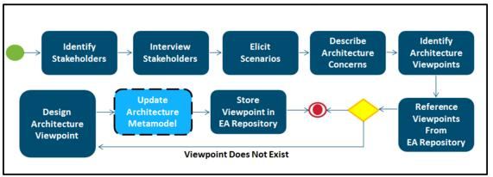
Figure 19: Process model to update content in the EA Repository

The TOGAF® methodology recommends that an enterprise architecture repository be populated with the following types of views.
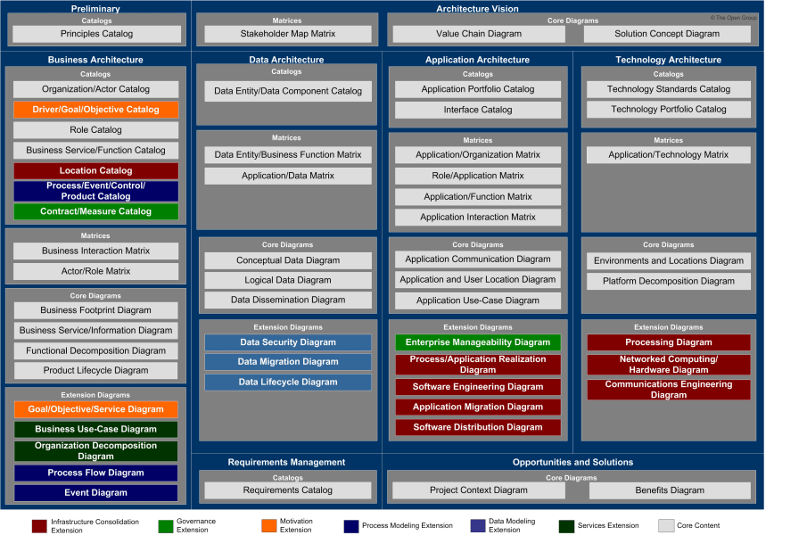
Figure 20: TOGAF viewpoints
Source: http://pubs.opengroup.org/architecture/TOGAF®9-doc/arch/Figures/35_viewpoints.png

Enterprise Architecture Reference Content

Reference Architectures
Reference Architectures (RAs) are the means through which the NextGen HR & PAY Enterprise Architecture Framework provides best-practice-based architectural solutions to build common business and/or technical capabilities. RAs facilitate repeatable solutions leading to shared solutions. They also provide a key mechanism to prevent unchecked acceptance of too many different solutions, dilution of the talent pool, challenges in the ability to leverage solutions across business units, and increasing support and maintenance costs. RAs are described in separate documents which are or will be made available through the enterprise EA standards publication process.

Current State Architecture
The current state architecture views represent the current state or baseline for the enterprise and consist of the following models:
- Current Business Architecture – it describes the current state business capabilities and the business process model
- Current Information Architecture – it describes the structure of an organization's existing logical and physical data assets and data management resources supporting the business processes
- Current Applications Architecture – it describes what applications are in place to manage the information and support the business processes including their key components and interactions
- Current Technology Architecture – it describes what logical software and hardware capabilities and what networks providing communication paths are in place to support the business, information, and application services additionally, current state architecture views also represent the motivational elements pertaining to the current state as (identified) assessments, requirements, and constraints. The type and depth of documentation of the above models should be guided by the need for detail and answers to questions about requirements, benefits, alternatives, applicable standards, and available resources while making sure that the EA focus is on business outcomes and is not diverted to documentation.

Target State Architecture
The future state architecture views represent the future state (or "to be built" state) of the enterprise within the context of the strategic direction and the operating model and consist of the following models:
- Future Business Architecture – it describes the future state business capabilities and the business process model
- Future Information Architecture – it describes the structure of an organization's logical and physical data assets and data management resources required to support the future state business process model
- Future Applications Architecture – it describes what application systems are necessary and relevant to the enterprise and how those multiple applications work together to support the future state business process model and manage the information
- Future Technology Architecture – it describes what logical software and hardware capabilities and what networks providing communication paths will be necessary and relevant to the enterprise to support the future state business process model, information, and application services Additionally, future state architecture views also identify the motivational elements pertaining to the future state and relate them to other architecture elements.
The type and depth of documentation of the above models will be guided by the need for detail and answers to questions about objectives, requirements, applicable standards, timeframes, and resources.

Architecture Assessments
Ensuring the compliance of investments with the enterprise architecture is an essential aspect of architecture governance.
Figure 21: Architectural Governance for Projects

Architecture Significance Details
Investments will have their architectures impacted for their degree of architecture significance. The architecture significance of an investment can be measured across multiple dimensions.

Strategic Technical Value
A measure of the value of the solution to the overall technology strategy of the enterprise.

Total Cost
An approximate measure of the total cost of the solution.

Complexity
A measure of the technical complexity of the solution.

Enterprise Impact
A measure of the overall impact of the solution on the functioning enterprise.

Criticality
A measure of the tactical necessity of the solution to the overall business.

Vendor Involvement
A measure of the impact or influence that third-party vendors have on the solution.

Examples of guiding architecture domain questions to help determine the architecture significance.
1 | Business Architecture  - Address significant gaps in business capabilities.  - Represents a new strategic business capability.  - How many access channels, organizations, citizens, or clients are impacted?
2 | Information Architecture  - Introduces new subject areas.  - Creates duplication of information.  - Requires a new data mart or data warehouse model.  - Is the solution required to handle very high volumes of data or transactions?
3 | Application Architecture  - What is the level of integration with existing hardware or software?  - Does the investment duplicate existing applications?
4 | Technology Architecture  - New or immature technology is being used.  - Amount of technical interfaces that require testing.  - Does the solution have significant network (e.g., bandwidth, topology) implications?
5 | Security Architecture  - What is the data classification?  - Does the solution require exchanging data with external partners?
6 | Cost, Risk and Complexity  - Is this investment cost considered high?  - Do the teams involved have experience with this type of implementation?

Application Portfolio Management
Portfolio rationalization aims to analyze and restructure the complete set of applications in an organization. It involves assessing and evaluating the existing portfolio and planning actions to streamline the portfolio in order to achieve the following:
- Improve efficiency
- Reduce complexity
- Lower Total Cost of Ownership
Streamlining portfolio is accomplished by the following:
- Retiring aging and low business value applications
- Modernizing aging and high business value applications
- Eliminating redundant applications and technologies
- Standardizing on common technology platform
- Consolidating the applications either physically, logically, or both
In the context of Enterprise Architecture, carrying out Portfolio Rationalization involves the following steps:
- Develop the business process model (of the business architecture):
  - Identify the maturity level of each business process.
  - Capture business capabilities and processes to identify redundancies, gaps and inefficiencies in the portfolio.
  - Use this information and the learning from assisting with the business and IT strategies to prioritize the areas for focus.
- Understand the Operating Model and Target Architecture Maturity
- Understand/develop architecture principles and standards
Develop future state architecture vision
- Define a strategy and scope for portfolio rationalization
- Rationalize the portfolio (Inventory and Map, Analyze and Recommend)
The Government of Canada’s Application Portfolio Management process will influence how application portfolio management is performed for NextGen HR & PAY.

Appendices

Simplified Enterprise Architecture Framework

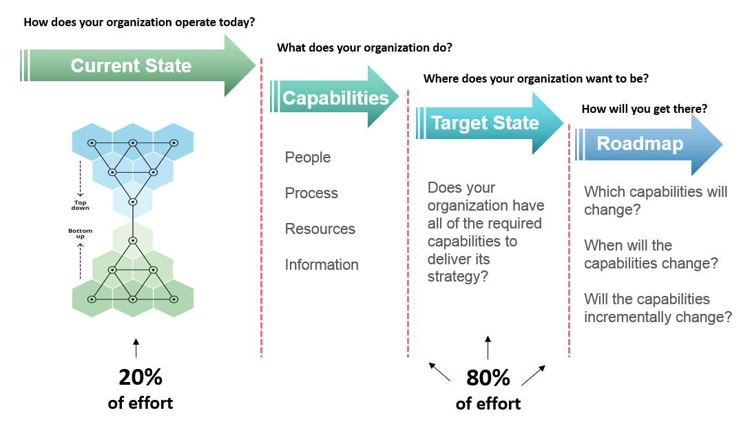
Figure 22: Simplified Enterprise Architecture Framework

Simplified Current State Architecture Framework
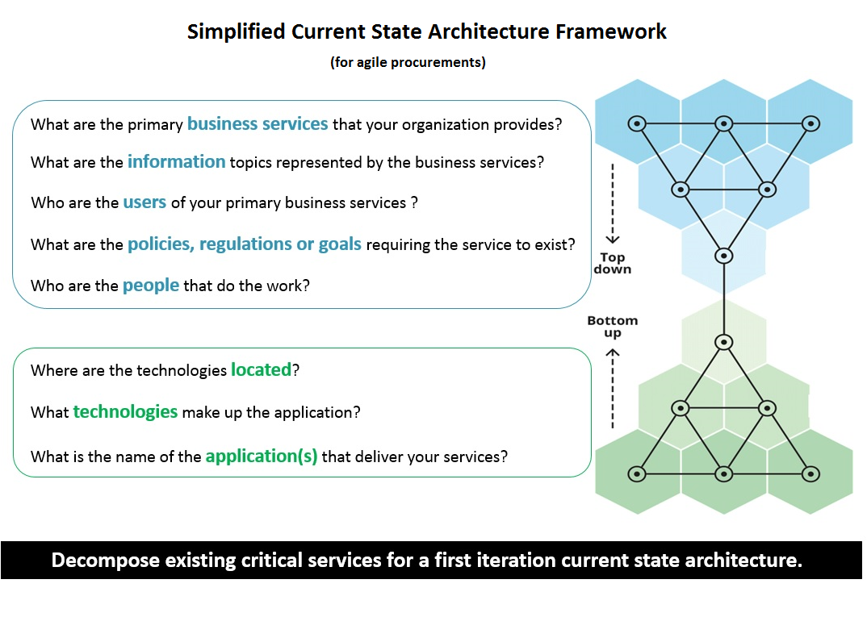
Figure 23: Simplified Current State Architecture

Architecture Elaboration

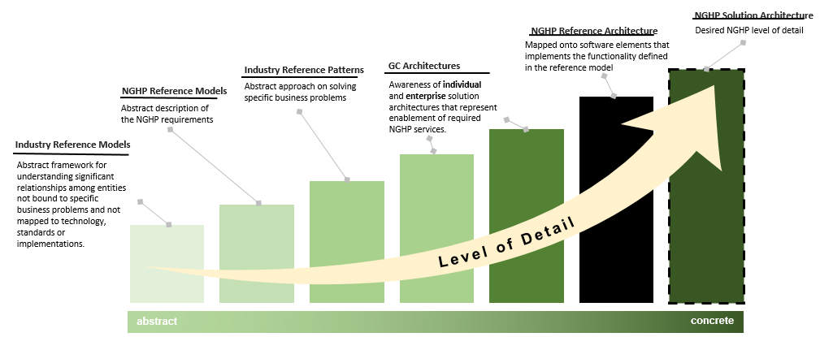

References
- The Open Group Architecture Framework (TOGAF)
  - http://pubs.opengroup.org/architecture/togaf9-doc/m/mobile-index.html

- The Open Group Architecture Framework – Maturity Model
  - https://pubs.opengroup.org/architecture/togaf9-doc/arch/chap45.html#tag_45_03

- MIT Operating Model
  - http://cisr.mit.edu/files/2009/12/Topic-EA_slide1_lg.png

- ArchiMate 3.0.1
  - http://pubs.opengroup.org/architecture/archimate3-doc/

- Government of Canada Enterprise Security Architecture Framework
  - http://www.gcpedia.gc.ca/wiki/Government_of_Canada_Enterprise_Security_Architecture_(ESA)_Program

- Managing Successful Programs (MSP)
  - https://www.axelos.com/best-practice-solutions/msp/what-is-msp

- Information Technology Information Library (ITIL)
  - https://www.axelos.com/best-practice-solutions/itil

- Government of Australia Enterprise Architecture Guide
  - https://www.finance.gov.au/policy-guides-procurement/australian-government-architecture-aga/

Glossary
Refer to TOGAF® 9.1 definitions as the authoritative source.
http://pubs.opengroup.org/architecture/TOGAF®9-doc/arch/chap03.html#tag_03_16

Contact

http://www.tbs-sct.gc.ca/next-gen-prochaine/next-generation-human-resources-pay-system-public-service.html

